Data Flow Diagram

Date | 30.09.2026
Team ID | SWTID-2026-3428
Project Name | AI FITTRACK
Maximum Marks | 2 Marks

Data Flow Diagram
Create a Data Flow Diagram (DFD) to show how data moves through your system - between external entities, processes, and data stores. Use the symbol legend below as a guide.

DFD Symbol Legend

Symbol | Name | Description
Oval / Rounded shape | External Entity | A person, organization, or system outside the project that sends or receives data (e.g., Customer, Payment Gateway).
Rectangle with  numbered header | Process | An activity that transforms incoming data into outgoing data (e.g., Validate Request, Process Order).
Rectangle (solid fill, no number) | Data Store | A place where data is held for later use (e.g., Customer Database, Inventory).
Labeled arrow | Data Flow | The movement of data between entities, processes, and data stores, labeled with what data is being passed.

Example
The diagram below illustrates how the symbols above come together to form a complete data flow diagram.
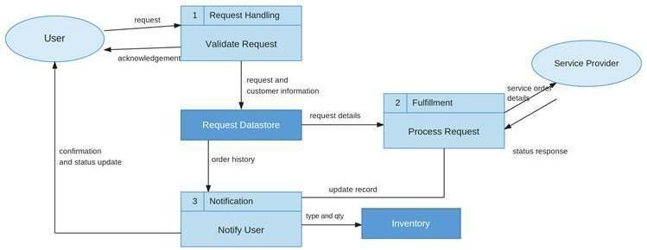

FitSense Data Flow Diagram – Level 0 / Logical DFD
External Entity: User / Client Application
Sends registration, login, profile, workout, search, AI recommendation, and fitness insight requests. Receives JSON responses.
Process 1: User Authentication
Receives registration/login data, validates credentials, hashes passwords using bcrypt.js, generates/verifies JWT tokens, and returns authentication results.
Process 2: Workout Management
Receives authenticated workout data and performs add, retrieve, update, delete, and search operations.
Process 3: AI Recommendation & Fitness Insights
Receives age, fitness goal, experience level, and workout statistics; sends prompts to Google Gemini AI and returns personalized recommendations and fitness insights.
Data Store D1: MongoDB – Users Collection
Stores user authentication and profile information such as name, email, encrypted password, and timestamps.
Data Store D2: MongoDB – Workouts Collection
Stores workout records including user reference, workout name, category, duration, calories burned, workout date, and timestamps.
External System: Google Gemini AI
Receives structured fitness prompts and returns personalized workout plans, exercise suggestions, training tips, safety recommendations, performance analysis, improvement suggestions, and motivational advice.

Data Flow Sequence
1. User / Client → User Authentication: registration or login data.
2. User Authentication → MongoDB Users Collection: validated user data and encrypted password.
3. MongoDB Users Collection → User Authentication: stored user information for authentication.
4. User Authentication → User / Client: JWT token and authentication response.
5. User / Client → Workout Management: authenticated workout request with JWT token.
6. Workout Management → MongoDB Workouts Collection: create, read, update, delete, or search workout data.
7. MongoDB Workouts Collection → Workout Management: requested workout records.
8. Workout Management → User / Client: standardized JSON workout response.
9. User / Client → AI Recommendation & Fitness Insights: age, fitness goal, experience level, or workout statistics.
10. AI Recommendation & Fitness Insights → Google Gemini AI: structured fitness prompt.
11. Google Gemini AI → AI Recommendation & Fitness Insights: AI-generated recommendation or fitness insight.
12. AI Recommendation & Fitness Insights → User / Client: personalized fitness response in JSON format.

DFD Summary
The FitSense data flow starts with the User/Client Application and passes through the Express.js backend. Authentication requests are handled through JWT-protected authentication processes. Workout information is stored and retrieved from MongoDB through Mongoose models. AI requests are sent through the dedicated service layer to Google Gemini AI, and the generated results are returned to the client as structured JSON responses.

